Unit 1. “Jobs”
Guía n° 2 English Language I° B - C

Nombre: |  |  |  | Curso: | Ist grade | Fecha
Puntaje Evaluación |  |  | Puntaje de corte (60%):
Puntaje obtenido: |  |  | Calificación:

INSTRUCCIONES:
- No se podrá entregar la guía sin estar resuelta completamente.
- La guía puede ser resuelta con apoyo de un diccionario. No está permitido copiar trabajos de otros compañeros/as.
- La guía debe ser entregada el día Jueves 6 de Abril

Objetivos: Reproducción Escrita
Contenidos: Vocabulario relacionado a el mundo del trabajo

I. Vocabulary
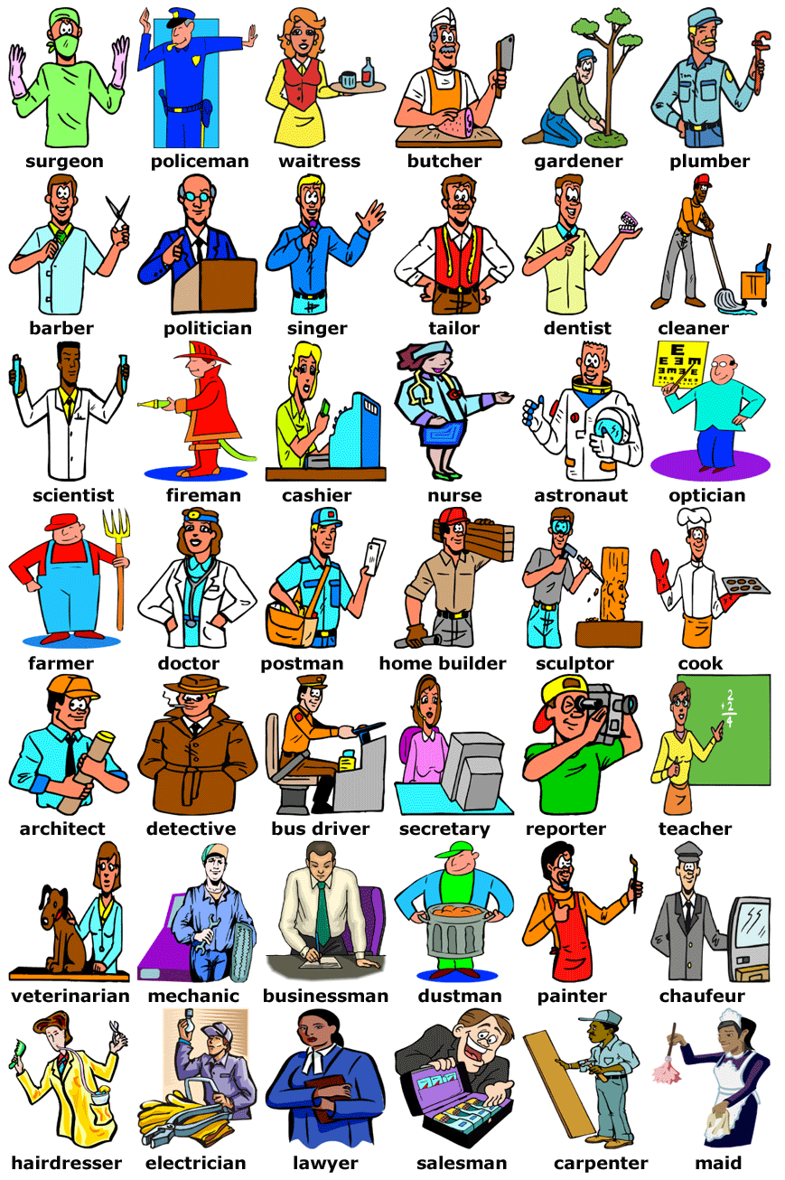
a) Look these images related to occupations and professions. Is any of your interest? Why?

II. Examples
a) Look at the examples about professions and occupations. Is someone you know have one of these profession or occupation?
The electrician came and changed our house wires | 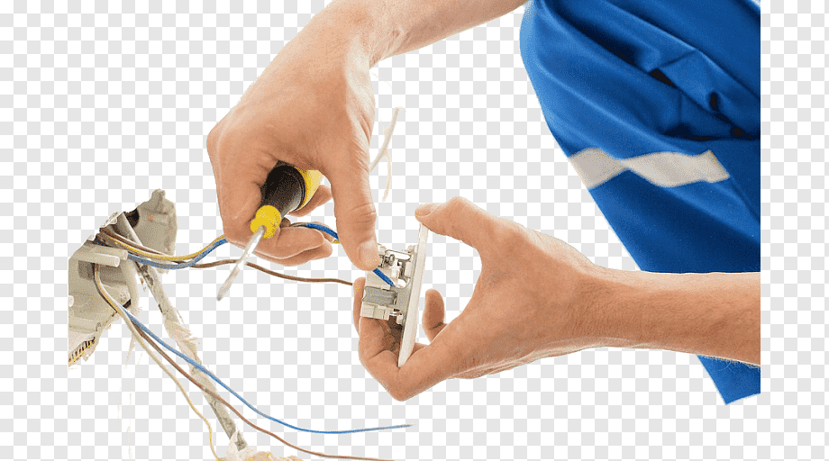
The waitress asked our order | 
When I was younger I wanted to be an astronaut | 
The surgeon is at the surgery room | 
Sandra the veterinarian is taking care of Firulais | 
The dustman labor is hard | 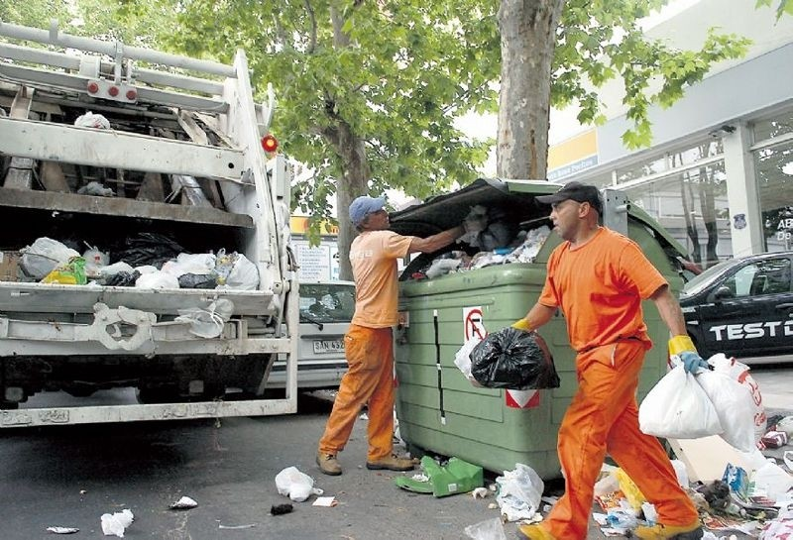
Catalina wants to be a mechanic | 
The cook created a new dish | 
The saleswoman offers 50% off on smartphones | 

Videos:
Jobs and Occupations Vocabulary
https://www.youtube.com/watch?v=xghGq87MNtY

III. Exercises
- Highlight the correct option for each occupation or profession

1. The person who is certified to treat our teeth is a:
a) plumber b) farmer c) dentist
2. Michael repairs cars. He is a:
a) mechanic b) paramedic c) auctioneer

3. Brad Pitt plays in movies. He is an:
a) puppeteer b) actor c) magician
4. The person who brings our mail is a:
a) post man b) journalist c) delivery boy

5. He takes pictures at different occasions. He is a:
a) director b) operator c) photographer

6. Mary dances at the opera. She is a:
a) ballerina b) dancer c) pianist

7. She makes clothes for people. She is a:
a) constructor b) tailor c) inventor

8. David Beckham is a famous sportsman. He is a:
a) referee b) DJ c) footballer

9. He works on a cargo ship. He is a:
a) sailor b) shepherd c) janitor
10. Peter mixes music in a disco. He is a:
a) manager b) DJ c) violinist

11. The person who designs buildings is an:
a) drummer b) lawyer c) architect

12. He works in a restaurant, preparing drinks. He is a:
a) waiter b) receptionist c) bartender

13. My friend writes articles for a local newspaper.
He is a: a) journalist b) writer c) inventor

14. She works in a hotel, at the front desk. She is a:
a) housewife b) waitress c) receptionist

15. He looks after sheep. He is a:
a) surgeon b) shepherd c) vet

16. She presents the weather forecast. She is a:
a) hairdresser b) model c) weather presenter

17. She operates a telephone switchboard. She is an:
a) operator b) doctor c) surgeon

18. He prepares food in a restaurant. He is a:
a) waiter b) cook c) gardener
19. He fights fires. He is a:
a) farmer b) lawyer c) fireman

20. He digs in the ground for coal and minerals. He is a:
a) driver b) miner c) plumber

21. She sells houses and land for other people.
She is a: a) realtor b) nun c) sales assistant

22. The person who is cutting down trees is a:
a) dealer b) usher c) lumberjack

23. The person who arranges women’s hair is a:
a) sculptor b) hair dresser c) housewife

- Fill in the sentences with a job from the word bank:
Lawyer - Nurse - Captain -Electrician - Singer Rescuer – Judge – Doctor – Archaeologist - Magician -Teacher – Priest – Vet - Bank Manager - Director - Nun -Janitor – Auctioneer - Camera Man
Police Officer – Fisherman - Waiter - Reporter Conductor - Pilot

- The_________________ sentenced the thief to 3 years in prison.
- The_________________ found a very old vase on the site.
- The_________________ of the ship decided to lower the life boats.
- They________________ were happy that the signed for the loan.
- The_________________ filmed the debate on tape.
- The _________________ presented his case before the jury.
- When she was 25 she decided to enter a convent and become a______________ .
- After the avalanche, they called in a _______________
- They liked her voice very much, so they gave her a 5 year contract as a______________ in their club.
- I have to take my dog to the________________ .
- The_____________ caught a lot of fish today.
- We saw a _______________ at the circus doing some good tricks.
- The________________ said that I should stay in bed for a few days.
- The________________ started the betting at 10 thousand dollars.
- They________________ hired a new at the opera.
- Who is the ________________ of this movie?
- We called the__________________ to check the alarm system.
- The killer was arrested by the _____________ .
- There were________________ many at the press conference.
- When she saw the serious condition of the patient, the______________ called in the doctor.
- The ________________ said that we have to do our homework for next week.
- The ________________landed the plane safely.
- The child was baptized by a young ____________ .
- The school ________________ cleaned the classrooms.
- Our ________________ forgot to bring our order.

- Match the sentences on the left with the ones on the right:

- I take care of babies when their parents are busy.
- I entertain children at parties and at the circus.
- I work on an air-plane. I serve food and drinks.
- I bring milk to people’s houses, in the morning.
- I work on an ambulance and I give first aid.
- I present news on the radio and I host radio shows.
- I write books which are published.
- I am the person who paints houses.
- I present designer clothes at fashion shows.
- I take care of people’s gardens.
- I give haircuts to men, and I shave them.
- I work on a crane, lifting heavy things.
- I work on the beach, making sure nobody drowns.
- I am a woman and I stay at home taking care of the house.
- I operate on people when they have health problems.
- I protect celebrities from dangerous fans or paparazzi.
- I work in a salon. I put make-up on people’s faces.
- I bring pizza to people’s houses.
- I make bread and pastry.
- I drive people around in a yellow car.
- I solve murder cases and I look for missing people.
- I sit at a desk and I answer the phone or send faxes. .
- I stay at the entrance of hotels, showing people in.
- I sell flowers or plants in pots.
- I am the person who drives the train or the tube.
- I make or I repair wooden structures and objects.
- I sell fresh vegetables at the market
- I work in a shop and I give information about products.
- I sculpt statues out of wood, rock or metal.
- I work in a casino and I deal the cards.

___ I am a florist.
___ I am a crane operator.
___ I am a dealer.
___ I am a radio host.
___ I am a delivery boy.
___ I am a greengrocer.
___ I am a detective.
___ I am a bodyguard.
___ I am a sales assistant.
___ I am a cab driver.
___ I am a sculptor.
___ I am a model.
___ I am a carpenter.
___ I am a milk-man.
___ I am a gardener.
___ I am a baby-sitter.
___ I am a barber.
___ I am an usher.
___ I am a train conductor.
___ I am a clown.
___ I am a secretary.
___ I am a flight attendant.
___ I am a baker.
___ I am a painter.
___ I am a lifeguard.
___ I am a writer.
___ I am a surgeon.
___ I am a paramedic.
___ I am a make-up artist.
___ I am a housew

